**Background**

The modern **Olympic Games** is a leading international sporting event featuring summer and winter sports competitions in which thousands of [athletes](https://en.wikipedia.org/wiki/Athletes) from around the world participate in a [variety of competitions](https://en.wikipedia.org/wiki/Multi-sport_event). The Olympic Games are considered the world's foremost sports competition with more than 200 nations participating. The Olympic Games are normally held every [four years](https://en.wikipedia.org/wiki/Olympiad), alternating between the [summer](https://en.wikipedia.org/wiki/Summer_Olympic_Games) and [Winter Games](https://en.wikipedia.org/wiki/Winter_Olympic_Games) every two years in the four-year period. From 241 participants representing 14 nations in 1896, the Games have grown to about 10,500 competitors from 204 nations at the [2012 Summer Olympics](https://en.wikipedia.org/wiki/2012_Summer_Olympics)

It is a known fact that Europe is the continent with the most Olympic medals (i.e. Gold, Silver and Bronze). Europe is also by far the continent with the most participants/athletes for the games. Figure (a) in the appendix below shows a significant disproportion in the number of Olympic athletes by the various continents since 1980.

**Research Question**

What has been the medal winning rate for the various continents over the past 36 years?

**Links to Data**

* https://www.kaggle.com/heesoo37/120-years-of-olympic-history-athletes-and-results/data
* <https://www.kaggle.com/heesoo37/120-years-of-olympic-history-athletes-and-results/data?select=noc_regions.csv>

**Graphical Findings**

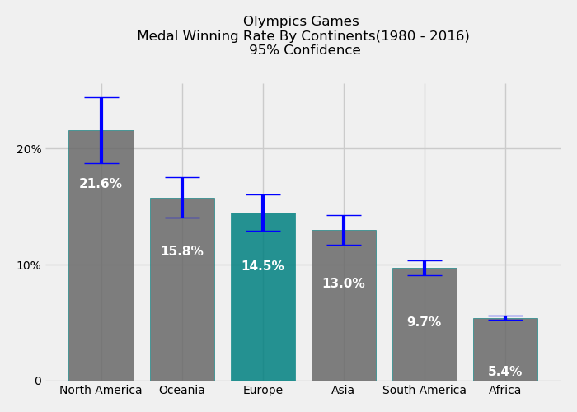

**Discussion**

This visualization was concerned with answering the question of the rate of winning Olympic medals by the various continents for the past 36 years. Kaggle was scraped for data concerning the past 36years history of the Olympic Games. Russia was assigned to Europe (i.e. Russia belongs to two continents: Europe and Asia). There was no segregation of the type of medal won by the various participants as the study was on medals in general. A 95% confidence error bar was added to help readers identify the certainty of the medal winning rates provided graphically above. ***Medal winning rate*** refers the ratio between the total medals won (i.e. Gold, Silver and Bronze) to total athletes for the various continents during a given Olympic season for the past 36years.

North America is by far the continent with the highest medal winning rate of 21.6%. North America is also the continent with the most uncertainty. This is followed by the Oceania, Europe and Asia with winning rates of 15.8%, 14.5% and 13.0% respectively. The medal winning rate for these three continents relative to each other is inconclusive with their error bars overlapping. In other words, one can to conclusively say which of the three continents have a better medal winning rates. South America and African followed respectively with the lowest rates of 9.7% and 5.4% respectively.

Even though Europe is the continent with the most medals and participating athletes per Olympic Games, North America out-performs them on the medal winning rate per participating athletes. With the same number of participating athletes, North America is very likely to significantly outperform the other continent including Europe

**Appendix**

***Medal winning rate*** refers the ratio between the total medals won (i.e. Gold, Silver and Bronze) to total participants for the various continents during a given Olympic season for the past 36years.

𝑀𝑒𝑑𝑎𝑙𝑊𝑖𝑛𝑛𝑖𝑛𝑔(𝑀𝑊𝑅)=((𝑇𝑜𝑡𝑎𝑙𝑀𝑒𝑑𝑎𝑙𝑠)/(𝑇𝑜𝑡𝑎𝑙𝑁𝑢𝑚𝑏𝑒𝑟𝑜𝑓𝑃𝑎𝑟𝑡𝑖𝑐𝑖𝑝𝑎𝑛𝑡𝑠))∗100

  
***Figure (a)***

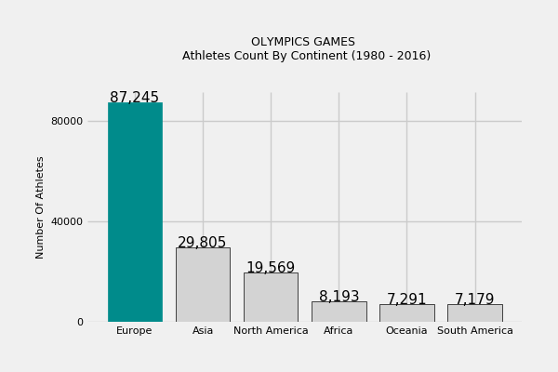

***Figure (a)***